**Assignment 16.1 Spark**

**Solution:**

2. Problem Statement

Given a list of numbers - List[Int] (1, 2, 3, 4, 5, 6, 7, 8, 9, 10)

**list =** ] (1, 2, 3, 4, 5, 6, 7, 8, 9, 10)

val x= sc.parallelize(List(1, 2, 3, 4, 5, 6, 7, 8, 9, 10))

* - find the sum of all numbers
* val y= x.sum

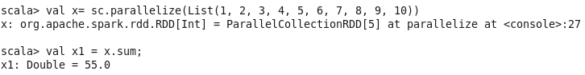

* find the total elements in the list
* val y =x.count



* - calculate the average of the numbers in the list
* val x1= sc.parallelize(List(1, 2, 3, 4, 5, 6, 7, 8, 9, 10))
* val y1 =x1.mean

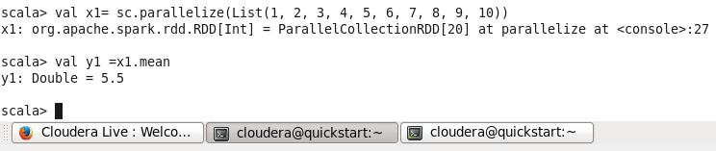

* - find the sum of all the even numbers in the list
* val y= x.filter(n => n%2 == 0)
* y.collect()
* val z1 = y.sum

